Experiment 1: 8 Puzzle Problem

Aim
To solve the 8-Puzzle Problem using the A* Search Algorithm.

Algorithm
- Define the initial state and goal state.
- Calculate the heuristic value using misplaced tiles or Manhattan distance.
- Locate the blank tile (0).
- Generate all possible child states by moving the blank tile.
- Store the states in a priority queue.
- Select the state with the minimum heuristic value.
- Repeat the process until the goal state is reached.
- Display the solution path.
Program
from queue import PriorityQueue
goal = [[1, 2, 3],
[4, 5, 6],
[7, 8, 0]]
# Heuristic Function (Misplaced Tiles)
def heuristic(state):
count = 0
for i in range(3):
for j in range(3):
if state[i][j] != 0 and state[i][j] != goal[i][j]:
count += 1
return count
# Find Blank Tile Position
def find_blank(state):
for i in range(3):
for j in range(3):
if state[i][j] == 0:
return i, j
# Generate Child States
def generate_moves(state):
x, y = find_blank(state)
moves = [(-1,0), (1,0), (0,-1), (0,1)]
children = []
for dx, dy in moves:
nx, ny = x + dx, y + dy
if 0 <= nx < 3 and 0 <= ny < 3:
new_state = [row[:] for row in state]
new_state[x][y], new_state[nx][ny] = \
new_state[nx][ny], new_state[x][y]
children.append(new_state)
return children
# A* Search Algorithm
def solve(start):
pq = PriorityQueue()
pq.put((heuristic(start), start))
visited = []
while not pq.empty():
h, current = pq.get()
if current == goal:
print("Goal State Reached:")
for row in current:
print(row)
return
visited.append(current)
for child in generate_moves(current):
if child not in visited:
pq.put((heuristic(child), child))
print("No Solution Found")
# Initial State
start = [[1, 2, 3],
[7, 5, 8]]
print("Initial State:")
for row in start:
print(row)
solve(start)
Output
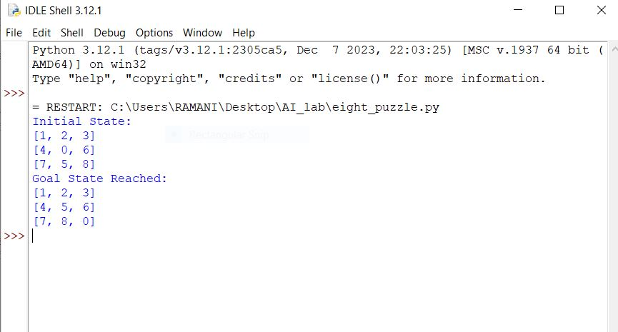

Result
Thus, the 8-Puzzle Problem was solved successfully using the A* Search Algorithm.

Experiment 2: 8 Queen Problem

Aim
To solve the 8-Queen Problem using the Backtracking Algorithm.

Algorithm
- Place a queen in the first column.
- Check whether the position is safe.
- If safe, place the queen and move to the next column.
- If no safe position exists, backtrack to the previous column.
- Repeat until all eight queens are placed.
- Display the chessboard with the queen positions.

Program

N = 8

# Function to print solution

def print_solution(board):

for row in board:
print(" ".join("Q" if x else "." for x in row))
# Check if a queen can be placed
def is_safe(board, row, col):
# Check left side of row
for i in range(col):
if board[row][i]:
return False
# Check upper diagonal
i, j = row, col
while i >= 0 and j >= 0:
if board[i][j]:
return False
i -= 1
j -= 1
# Check lower diagonal
i, j = row, col
while i < N and j >= 0:
if board[i][j]:
return False
i += 1
j -= 1
return True
# Solve using backtracking
def solve(board, col):
if col >= N:
return True
for row in range(N):
if is_safe(board, row, col):
board[row][col] = 1
if solve(board, col + 1):
return True
board[row][col] = 0
return False
# Main Program
board = [[0 for _ in range(N)] for _ in range(N)]
if solve(board, 0):
print("Solution Found:\n")
print_solution(board)
else:
print("No Solution Exists")

Output
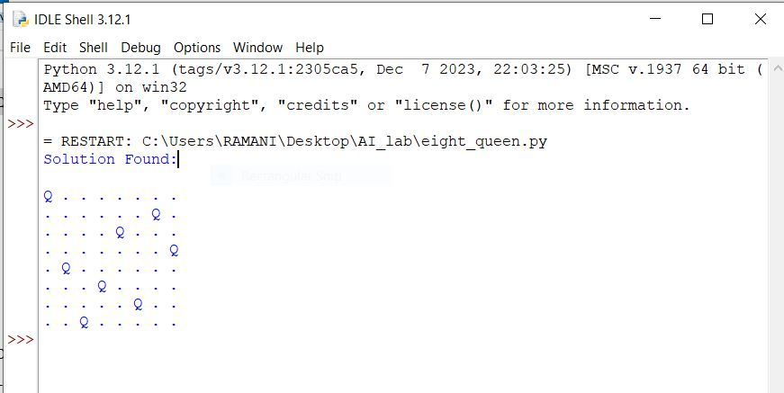

Result
Thus, the 8-Queen Problem was solved successfully using the Backtracking Algorithm.

Experiment 3: Water Jug Problem

Aim
To solve the Water Jug Problem using State Space Search.

Algorithm
- Consider two jugs with capacities 4 liters and 3 liters.
- Fill one of the jugs completely.
- Transfer water between jugs according to the rules.
- Empty and refill jugs whenever necessary.
- Continue generating new states.
- Stop when the required quantity of water is obtained.
- Display all intermediate states.
Program
def water_jug():
jug1 = 0
jug2 = 0
cap1 = 4
cap2 = 3
print("(Jug1, Jug2)")
# Fill Jug2
jug2 = cap2
print((jug1, jug2))
# Pour Jug2 into Jug1
jug1 = jug2
jug2 = 0
print((jug1, jug2))
# Fill Jug2 again
jug2 = cap2
print((jug1, jug2))
# Pour Jug2 into Jug1 until Jug1 is full
transfer = cap1 - jug1
jug1 = cap1
jug2 = jug2 - transfer
print((jug1, jug2))
# Empty Jug1
jug1 = 0
print((jug1, jug2))
# Transfer remaining water from Jug2 to Jug1
jug1 = jug2
jug2 = 0
print((jug1, jug2))
# Fill Jug2
jug2 = cap2
print((jug1, jug2))
# Pour Jug2 into Jug1
transfer = cap1 - jug1
jug1 = jug1 + transfer
jug2 = jug2 - transfer
print((jug1, jug2))
print("\nGoal Achieved: 2 Liters in Jug2")
water_jug()
Output
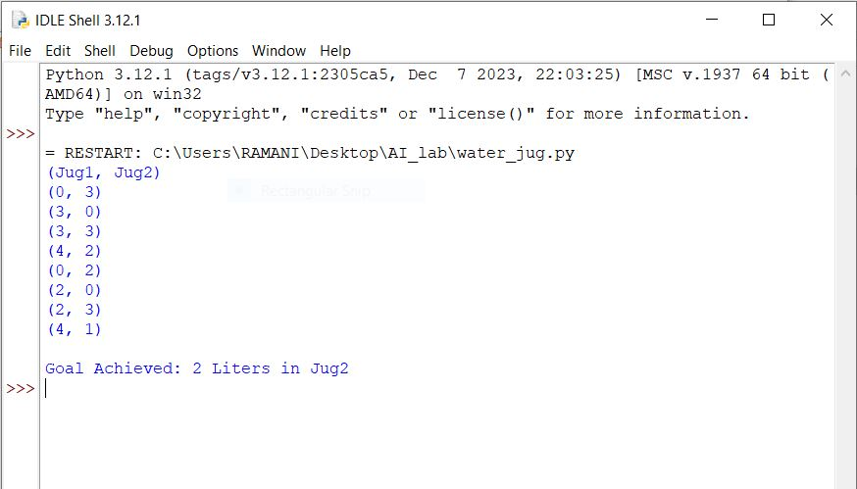

Result
Thus, the Water Jug Problem was solved successfully and the desired quantity of water was obtained.

Experiment 4: Crypt Arithmetic Problem

Aim
To solve the Crypt Arithmetic Problem (SEND + MORE = MONEY) using Artificial Intelligence techniques.

Algorithm
- Identify all unique letters in the given expression.
- Assign unique digits to each letter.
- Ensure that leading letters are not assigned zero.
- Generate all possible digit combinations.
- Check whether the arithmetic equation is satisfied.
- If the equation is satisfied, display the solution.
- Otherwise continue searching until a valid solution is found.
Program
from itertools import permutations
letters = ('S', 'E', 'N', 'D', 'M', 'O', 'R', 'Y')
for p in permutations(range(10), 8):
S, E, N, D, M, O, R, Y = p
# Leading digits cannot be zero
if S == 0 or M == 0:
continue
send = 1000*S + 100*E + 10*N + D
more = 1000*M + 100*O + 10*R + E
money = 10000*M + 1000*O + 100*N + 10*E + Y
if send + more == money:
print("Solution Found:")
print("SEND =", send)
print("MORE =", more)
print("MONEY =", money)
Break
Output
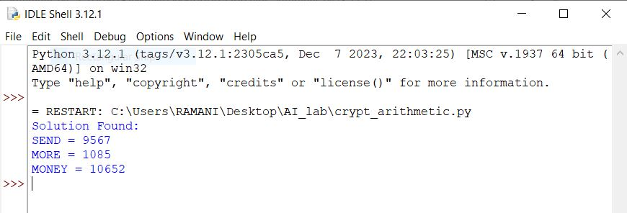

Result
Thus, the Crypt Arithmetic Problem was solved successfully and the correct digit assignment was obtained.

Experiment 5: Missionaries and Cannibals Problem

Aim
To solve the Missionaries and Cannibals Problem using Breadth First Search (BFS).

Algorithm
- Represent the initial state as three missionaries and three cannibals on the left bank.
- Define all possible boat movements.
- Check whether a state is valid.
- Generate successor states.
- Use BFS to explore states level by level.
- Avoid revisiting already explored states.
- Continue until the goal state is reached.
- Display the solution path.
Program
from collections import deque

# Initial state: (Missionaries Left, Cannibals Left, Boat Side)
start = (3, 3, 1)
# Goal state
goal = (0, 0, 0)
# Possible boat moves
moves = [(1,0), (2,0), (0,1), (0,2), (1,1)]
def is_valid(m, c):
# Check limits
if m < 0 or c < 0 or m > 3 or c > 3:
return False
# Left bank condition
if m > 0 and m < c:
return False
# Right bank condition
mr = 3 - m
cr = 3 - c
if mr > 0 and mr < cr:
return False
return True
def bfs():
queue = deque([(start, [])])
visited = set()
while queue:
state, path = queue.popleft()

if state == goal:
return path + [state]
if state in visited:
continue
visited.add(state)
m, c, boat = state
for dm, dc in moves:
if boat == 1: # Boat on left side
new_state = (m - dm, c - dc, 0)
else: # Boat on right side
new_state = (m + dm, c + dc, 1)
nm, nc, _ = new_state
if is_valid(nm, nc):
queue.append((new_state, path + [state]))
return None
solution = bfs()
print("Solution Path:")
for step in solution:
print(step)

Output
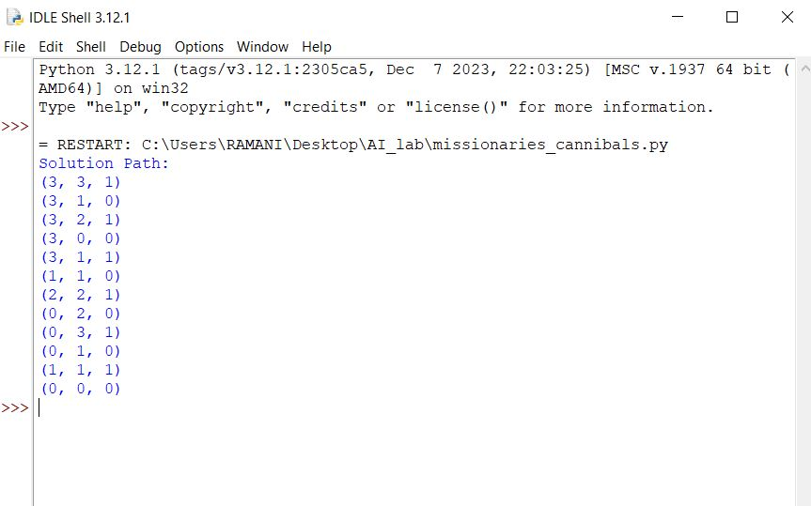

Result
Thus, the Missionaries and Cannibals Problem was solved successfully using Breadth First Search (BFS).
Experiment 6 : Vaccum cleaner problem

Aim
To implement the Vacuum Cleaner Problem using a Simple Reflex Agent.

Algorithm
- Start with two rooms A and B.
- Check the current room status.
- If the room is dirty, clean it.
- Move to the next room.
- Repeat the process until all rooms are clean.
- Display the final state.
Program
# Vacuum Cleaner Problem
# Room A and Room B status
rooms = {
'A': 'Dirty',
'B': 'Dirty'
}
# Vacuum starts at Room A
location = 'A'
print("Initial State:")
print("Room A =", rooms['A'])
print("Room B =", rooms['B'])
print()
# Cleaning process
while 'Dirty' in rooms.values():
if rooms[location] == 'Dirty':
print("Vacuum is in Room", location)
print("Cleaning Room", location)
rooms[location] = 'Clean'
# Move to next room
if location == 'A':
location = 'B'
else:
location = 'A'
print("\nGoal State Reached")
print("Room A =", rooms['A'])
print("Room B =", rooms['B'])

Output
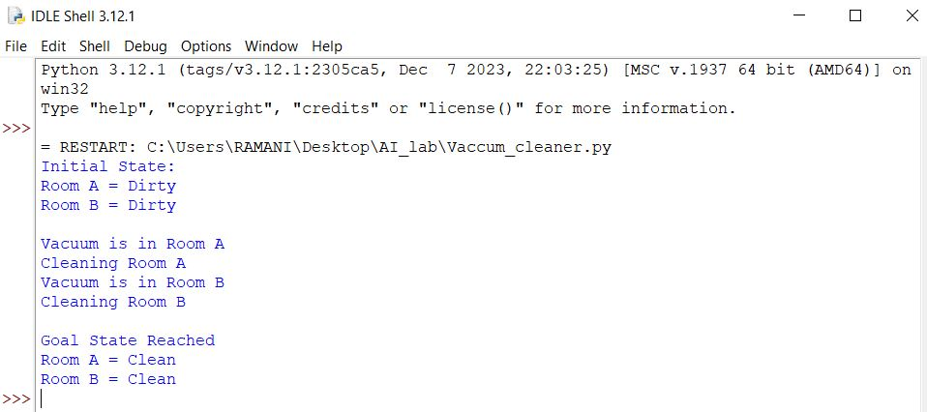

Result
Thus, the Vacuum Cleaner Problem was implemented successfully and all rooms were cleaned using a Simple Reflex Agent.

